8.14

Doing analysis on open pnl:

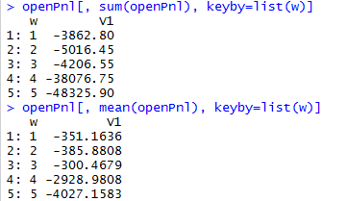

As can be seen, drop from thurs/fri mtm is huge. This means open pnl and am should all be hedged.

This means you should cut wed delta aggressively.

AM mean, range SD and sharpe.

AM wed-fri negative sharpe. Wed is the worst in terms of sharpe.

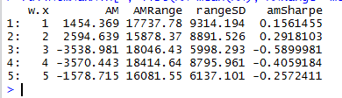

Thurs mean rangeSD and sharpe: tues is the best followed by thurs.

Fri is pointless. Mon is surprisingly negative which boosts Tuesdays pm.

Wed is surprisingly insipid.

